1. Variables:

- Numerical variable: R&D Spend, Administration, Marketing Spend, Profit

- Categorical variable: State

2. Distribution of Profit (output)

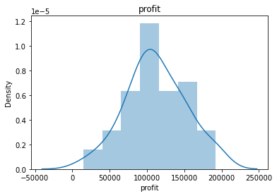

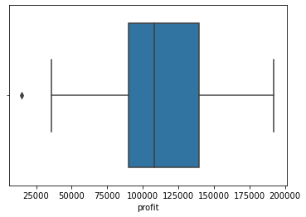

Profit shows a normal distribution with 1 outlier.

3. Distribution of numerical variables

i) Marketing Spend

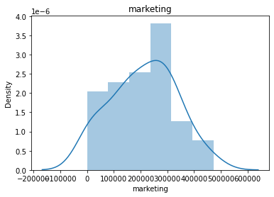

ii) Research Spend – Highest frequency around 50k – 100k ii) Administration

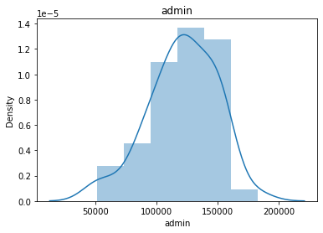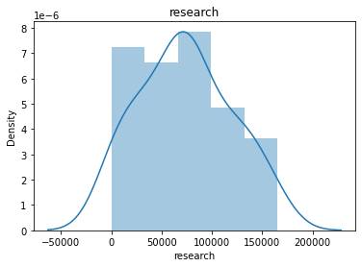

4. Multicollinearity between variables based on heatmap:

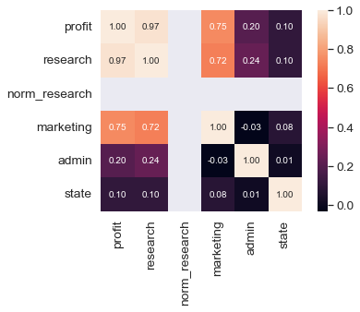

* Profit is highly correlated with  
   Research Spend and Marketing Spend
* Correlation between Research and  
   Marketing is 0.72

5. Categorical Variable – State (California – 0, Florida – 1, New York – 2)

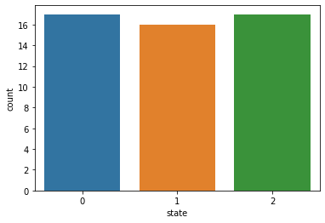

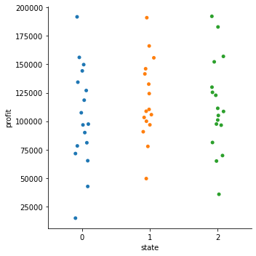

Profit range are quite the same across all state, so the feature can be removed from model.

|  |  |
| --- | --- |
| Model with state included | R2 = 0.946 |
| Model without state included | R2 = 0.948 |
| Model after removing outlier row (Profit) | R2 = 0.959 |